**Group Members: Yiran Wang, Yiwei lih, Swee Yee Han**

**0. Description of this document**

This short report shall document the processes involved in the creation of our final product, which is a series of maps relating to the underground carpark in SUTD.

The original question:

It is widely known that the carpark at SUTD main campus is underground, which is hard for people to see the distribution of each parking lot. Therefore, we are interested in seeking for the temporal and spatial patterns of cars in the carpark, and looking for the correlations (if any) between the parking location and car brand, parking direction, etc.

In addition, since SUTD is a new university with various visitors from time to time, we would like to find out the nearest exit and lift lobby for each parking lot, and provide drivers with the best parking lot in the carpark as well.

**1. Data collection**

For this project, due to the lack of readily-available data regarding the type of cars parked in the carpark as well as the unavailability of lot-level occupancy data, such data had to be collected manually. As such our group decided to record down our observations of the carpark, which included the following types of attributes of each car parked at each lot:

|  |  |  |  |
| --- | --- | --- | --- |
| Data | Description | Data type | Example |
| Brand of car | The brand of the car that is parked in the lot. Common car brands will be available for the data collector to select for faster data entry. If car brand is not in the list, then the data collector can add a new brand to the list. | Nominal, string | “Toyota”, “Kia” |
| HDB Season Parking01-rfid.jpg;waee7ed95392d7b90c | Whether or not a HDB season parking label (shown on the left) is present on the car. This will be used to infer if the car owner lives in public housing. | Interval, binary variable | 1 if label is present,  0 otherwise |
| Direction the car is parked | Whether the car is parked with its front facing into the lot or if its rear is facing into the lot. This will be used to find patterns in parking behaviors.  *“If you see the front of the car, it is 1. 0 otherwise”* | Interval, binary variable | 1 if car is backed in, 0 otherwise |

Collection of these data was done over several days, on a hourly basis from 8 am to 12 midnight. This process entailed us walking through the carpark each hour, recording down our observations regarding each parked car by voice and then subsequently listening to those recordings and simultaneously transferring that information into a Google spreadsheet. Such a process took approximately half an hour from start to end.

We also supplemented such data with the geometry of the carpark, in the form of a floor plan provided by Office of Campus Development, SUTD. This floor plan was then digitised and then redrawn in QGIS, such that each parking lot would be represented by a single polygon object.

A site-study of the carpark was also conducted in order to determine what attributes each parking lot would have; the selected attributes are whether each parking lot was designated for season parking only, electric vehicles only or for persons with disabilities only (these also turned out to be mutually exclusive).

**2. Data analysis**

*2.1 Distance from each parking lot to the nearest lift lobby*

With the digitised floor plan, we were able to utilise the tools of ArcGIS to determine the distance between each parking lot and each lift lobby, and ultimately determine the distance from each parking lot to the nearest lift lobby. This was done first by creating a virtual road network that was overlaid on the existing floor plan, which reflected how drivers would walk from their parked cars to the lift lobbies.

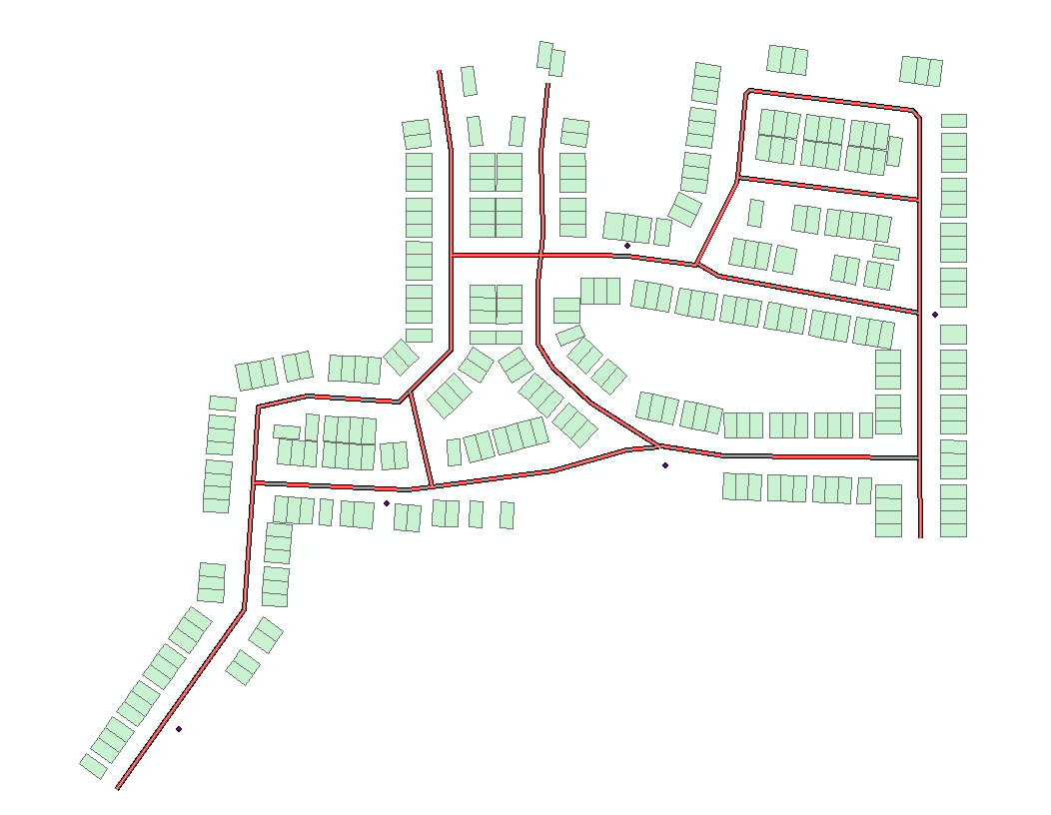

Then, the Network Analyst extension was used to create an Origin-Destination (OD) matrix that captures the distance from each parking lot to each lift lobby, which is stored as an attribute in a line object. From there, the lines representing the shortest distances from each lot to the nearest lift lobby was selected, resulting in the following diagram which shows where the nearest lift lobby is for each parking lot.

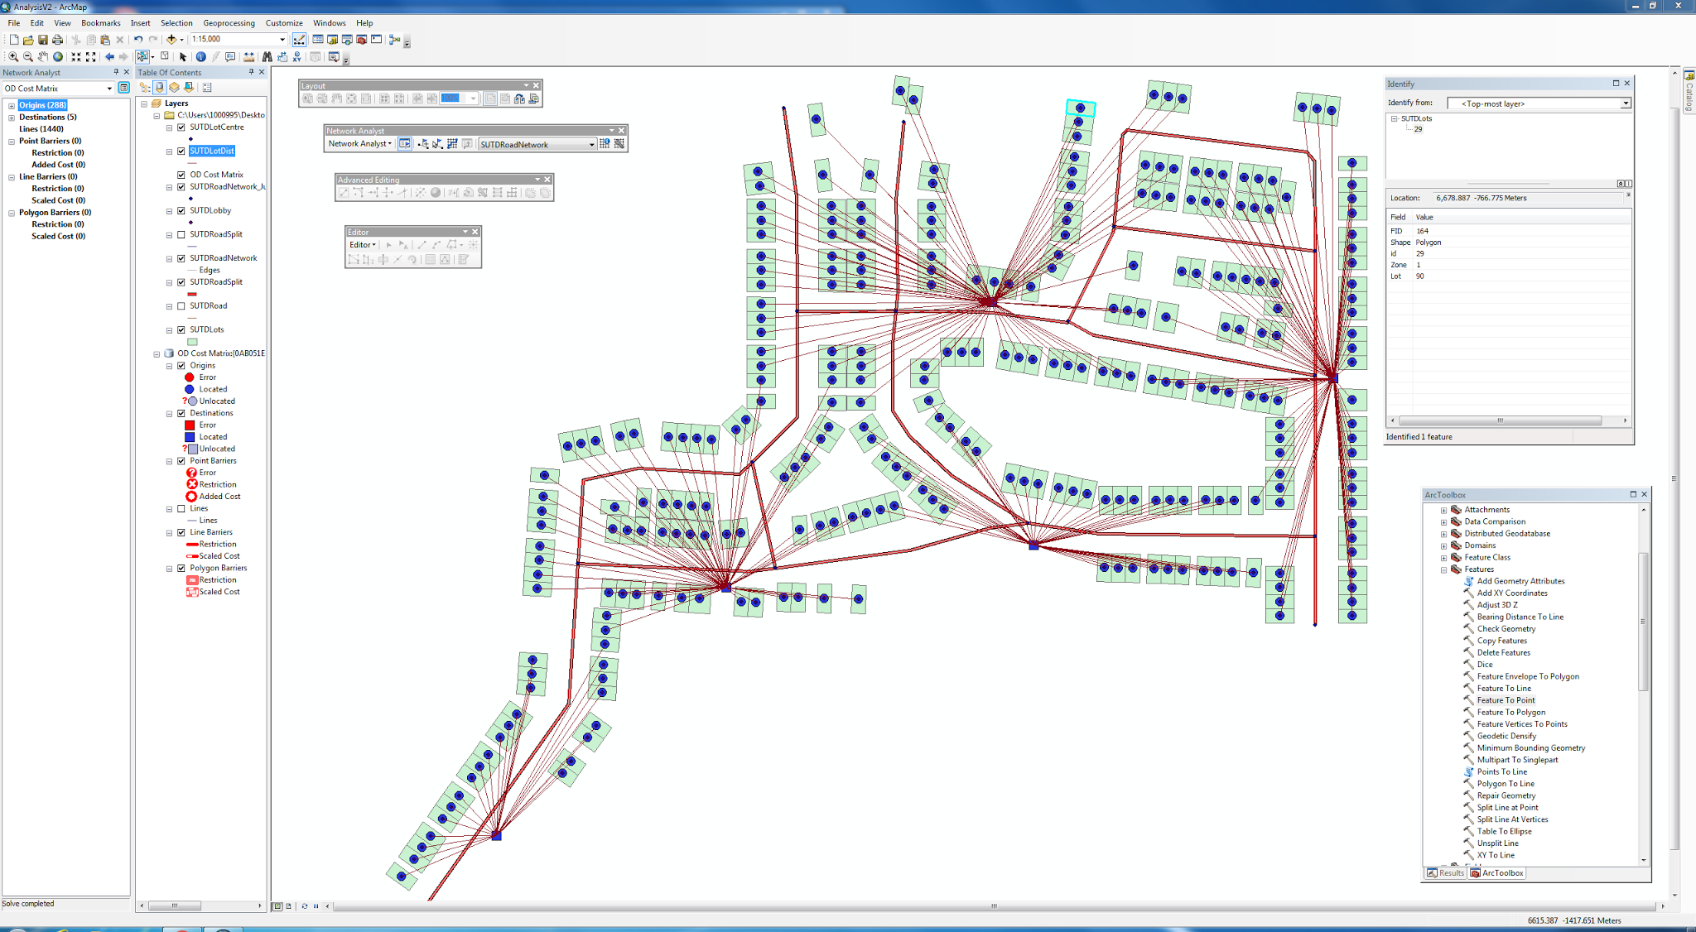

*2.2 Average occupancy calculations*

In our collected data, an empty entry implies no car was present, while a filled entry implies that a car was parked at that specific lot. Using this information, we were able to calculate occupancy rates in two ways; first by averaging the count of cars for each hour to determine average occupancy rates by the hour, second by averaging the count of cars for each lot to determine the average occupancy rates for each lot.

*2.3 Calculating an index that shows the “best place to park” in SUTD*

Upon consideration of all the data points that we collected in our study of the carpark, we decided that the terms that would make the most sense in an index determining where the best parking lot would be would comprise of the distance from the parking lot to the nearest lift lobby, and the average occupancy of the parking lot. Upon experimentation, we also found that giving both terms equal weightage would provide most interesting results, and as such decided to implement this for our final map.

*2.4 Other analyses that did not make it to the final product*

While we also collected data regarding the brand of cars, whether the car is parked backed into the parking lot or driven into the parking lot, and whether any HDB season parking label was present on the car, we ultimately decided not to include such analysis into our final product, as they would distract from the main point which was about creating an index that shows where the best places to park in SUTD would be, and we think that these data do not add value to the final product.

**3. Data visualization**

*3.1 Maps of SUTD and the underground carpark (Maps 1, 2, 3, 4)*

The purpose of showing these maps is to serve as a graphic introduction to the carpark in SUTD. Many people can instantly recognise the building outlines of SUTD (Map 1), yet the floor plan of the carpark looks very different to the floor plans above ground. As such, these maps would serve as a context for the viewer to orientate him or herself with the layout of the carpark (Maps 2, 4), its location relative to the buildings above-ground (Map 3), as well as the key features of the carpark (Map 4).

*3.2 Map of distance to nearest lift lobby (Map 5)*

The purpose of this map is to showcase the results of the analysis of distance from each parking lot to the nearest lift lobby. As such, we have decided to display two key attributes differently. The first was which lift lobby is the closest to the parking lots. Since this can be seen as the service area of a lift, we decided to colour the background of the carpark differently, thus marking out 5 zones (one for each lift lobby). The colours of these zones vary only by hue since the main attribute behind the choice of colours, the lift lobbies, can be considered as categorical. We also decided to colour each individual lot according to how far it is away from the nearest lift lobby. As such, since this variable is quantitative in nature, we decided to colour each individual lot in grey scale, with darker colours indicating a longer walk from the nearest lift lobby. The two colour schemes employed would also ensure that the same grey colour for each lot would look identical when surrounded by different colours that represent the service areas of each lift lobby.

*3.3 Map of carpark occupancy against time (Map 6)*

This map combines a line graph of the average occupancy of each lot over the course of a day with the spatial distribution of lot occupancy at particular time points. This layout is efficient in giving the viewer a sense of how the pattern of occupancy changes with time at the macro and micro level. The time points chosen (08:00, 15:00, and 20:00) are significant in telling the story of the rise and fall of occupancy in the carpark. The equal interval class break was chosen to provide consistency across the three time periods. A graduated orange colour scheme is used throughout the map to show the common theme of occupancy. The background of the line graph was coloured according to the chosen scale to incorporate it with the map’s class breaks. Callouts are used with short captions to guide the viewer to the relevant maps and give snippets of information about the possible reasons for the observed occupancy.

*3.4 Map of best parking lots in SUTD (Map 7)*

For this map, we decided to utilise the quantile scheme of class breaks as it would be the best choice for showcasing the relative ranks of individual lots according to our calculated index. For this index, the relative scores between lots are more important than their absolute scores, and a quantile scheme can easily show which are the top ranked parking lots relative to the other lots. As such a quantile scheme is superior to the other forms of class breaks.

**4. Limitations and Conclusions**

*4.1 Limitations*

The key limitation in our project was the non-availability of data sources. While the carpark has a lot occupancy tracking system that shows which parking lots are occupied and which ones are empty, this data is not stored anywhere and only aggregated information is displayed (e.g. a total of 160 lots are available). If our project had access to such a source of data, the data collection phase of the project would be greatly simplified and that would facilitate the collection of more days of data, hence improving the accuracy of average occupancy calculations.

*4.2 Conclusions*

We think that the final map would be useful for drivers who want to look for the ideal parking lots in SUTD. The intermediate map that shows where the nearest lift lobby for each parking lot would also be useful to drivers, especially drivers who are new to the carpark, and would allow them to orientate themselves with the carpark. Furthermore the university can consider colouring the pillars in the capark in a similar manner that was done on this map, so drivers would be able to know where they are and where the nearest lift lobby is with respect to their current location.

The maps on occupancy would also be useful for Office of Campus Development, which is in charge of managing the carpark. Such occupancy maps can aid with their decision on which lots can be converted from season lots into visitor lots, and vice versa. Thus, for instance they could consider converting under-utilized season parking lots into visitor lots, which could potentially allow more parking revenue to be generated for the university.